`



Software Architect Design

Van Lang Admissions

# Revision Table

|  |  |  |  |
| --- | --- | --- | --- |
| **Author** | **Date** | **Reason for changes** | **Version** |
| Hien Nguyen | 06/02/2017 | Initial the document | 1.0 |
| Hien Nguyen | 09/02/2017 | Fix physical view level 0 and level 1 | 1.1 |
| Khoi Nguyen | 24/5/2017 | Fix logo | 1.2 |
| Hien Nguyen  Khoi Nguyen | 27/5/2017 | Update Content  Update Template | 2.0 |
|  |  |  |  |

Table of Contents

Revision Table 1

1. INTRODUCTION 3

1.1. Purpose 3

1.2. Audience 3

2. System overview 3

2.1. Description 3

2.2. System context 3

3. PHYSICAL PERSPECTIVE 4

3.1. STAND ALONG VIEW 4

3.2. DEPLOYMENT VIEW 4

3.2.1 With 4 server 5

3.2.2 With 2 servers 6

4. STATIC PERSPECTIVE 7

4.1. PRIMARY PRESENTATION 7

4.2. DECOMPOSITION STYLE 9

4.2.1. Front end 9

4.2.2. Back end 9

5. DYNAMIC PERSPECTIVE 11

5.1. PRIMARY PRESENTATION 11

5.2. DECOMPOSITION STYLE 12

5.2.1. News 12

5.2.2. Account 15

5.2.3. Banner. 17

5.2.4. Category 19

5.2.5. Examination 21

5.2.6. Question 23

# INTRODUCTION

## Purpose

Overview about Architect Design of Project, help team understand about Architect of Project

## Audience

The intended audience of the AR Design is

|  |  |
| --- | --- |
| **Intended Audience** | **Description** |
| All team member | All member have a meeting and discuss about process |
| The mentor | People give an advice and support group during Architect process. |
| Stakeholder on customer side | People give requirement of project |

# System overview

## Description

* The following model is the system overview. The system overview presents the interface between the VLA system and users.
* VLA system include 6 features:
  + Manage Account
  + Manage News
  + Manage Category
  + Manage Examination
  + Manage Question
  + Manage Banner

## System context

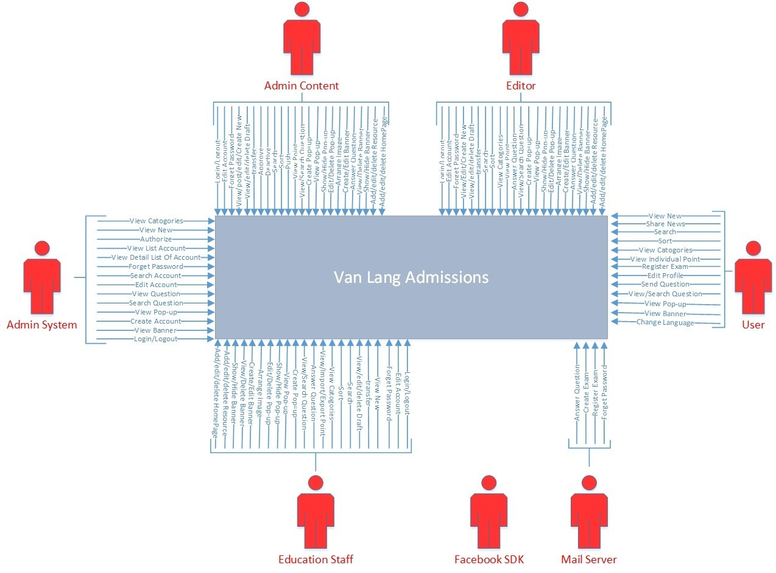

1. PHYSICAL PERSPECTIVE
   1. STAND ALONG VIEW

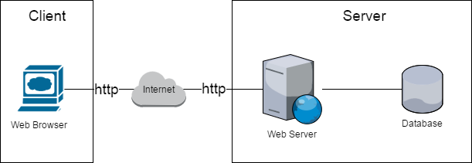

* 1. DEPLOYMENT VIEW

### 3.2.1 With 4 server

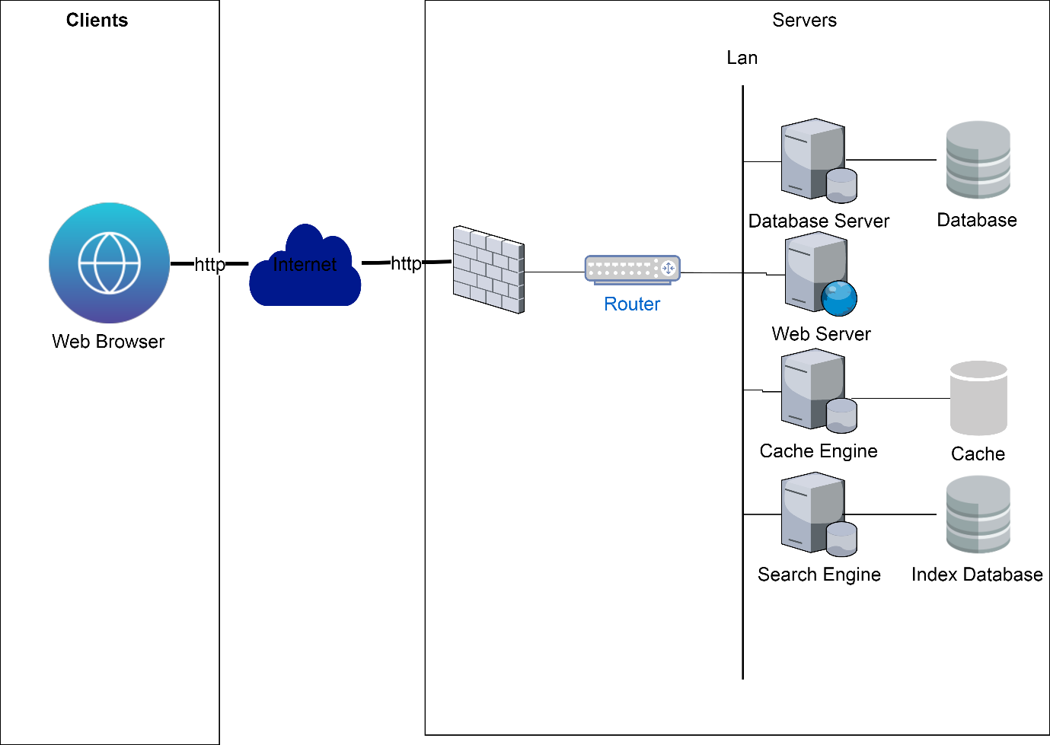

Evironment Elements

|  |  |  |  |
| --- | --- | --- | --- |
| **No** | **Name** | **Properties** | **Responsibilities** |
| 1 | Web Server | OS: Windows XP, 7  CPU: Intel dual core  RAM: 2G | Run VLA website, receive request and display data on website |
| 2 | Database Server | OS: Windows XP, 7  CPU: Intel dual core  RAM: 2G | Run database. |
| 3 | Database |  | Store all data of system |
| 4 | Cache Engine |  | Run cache. |
| 5 | Cache |  | Only store data of banners and categories. Help loading user website faster. |
| 6 | Search Engine |  | Run index database. |
| 7 | Index database |  | Only store data of news and question. Support search and select more quickly. |
| 8 | Firewall | Cisco | Firewall of router, helps to keep network secure, control the incoming and outgoing network traffic to secure database server of system. |
| 9 | Router | Cisco | Connect LAN with internet or WAN |
| 10 | LAN | Use switch to connect elements in LAN | Connect all servers |
| 11 | Internet |  |  |

Software Elements

|  |  |  |  |
| --- | --- | --- | --- |
| **No** | **Name** | **Properties** | **Responsibilities** |
| 1 | Nodejs | Version: v7.10.0 | Run web server and database server. |
| 2 | MongoDB | Version: v3.4.4 | Run database |
| 3 | Redis | Version: v3.2.100 | Run cache |
| 4 | Elasticsearch | Version: v5.3.0 | Run Index database |

### 3.2.2 With 2 servers

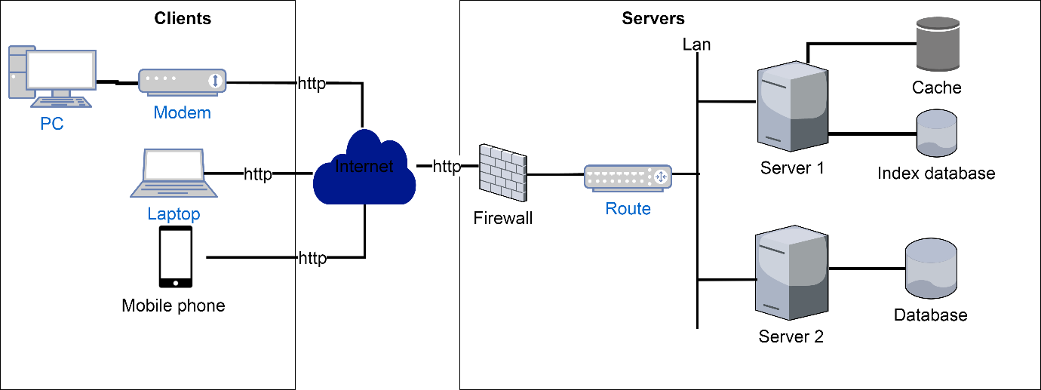

Rationale

|  |  |  |  |
| --- | --- | --- | --- |
| **No** | **Quality Attribute** | **Decision** | |
| 1 | Performance | We divide into many servers to handle all request from user. | |
| 2 | Availability | Firewall will prevent malicious attacks to avoid servers down. | |
| 3 | Scalability | The system can be expanded server. | |
| 4 | Portability | We use Ionic 2 and Angular 2 to display data on web browsers and mobile browsers | |
| Risk | | Trade off | Sensitivity point |
| * When internet down, internal users will be unable to connect to server. | | * When implemented, the system will be costly and difficult to install. |  |

1. STATIC PERSPECTIVE
   1. PRIMARY PRESENTATION

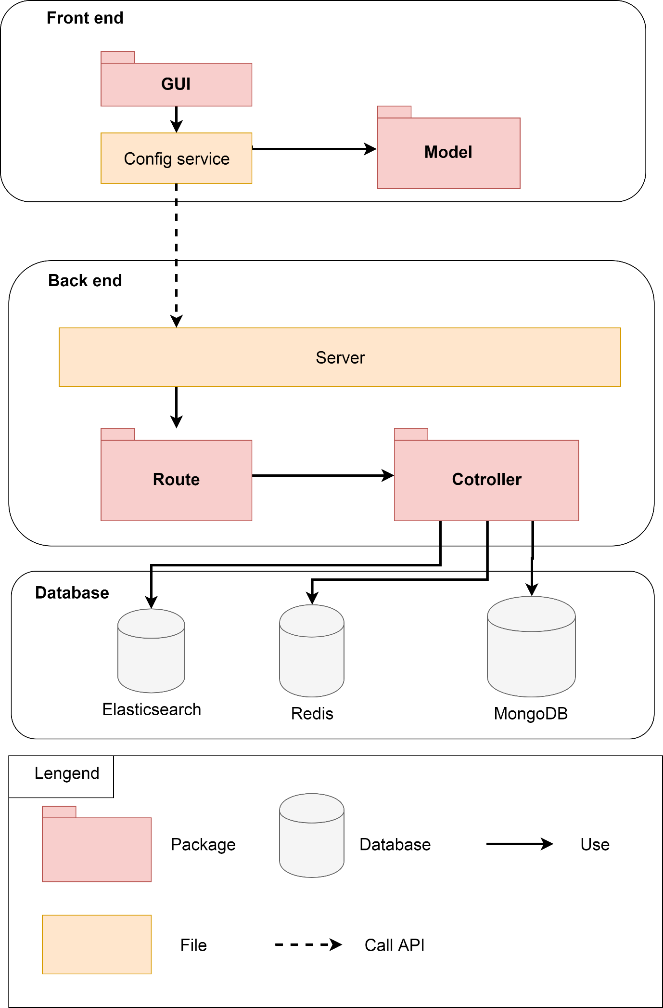

* 1. DECOMPOSITION STYLE
     1. Front end

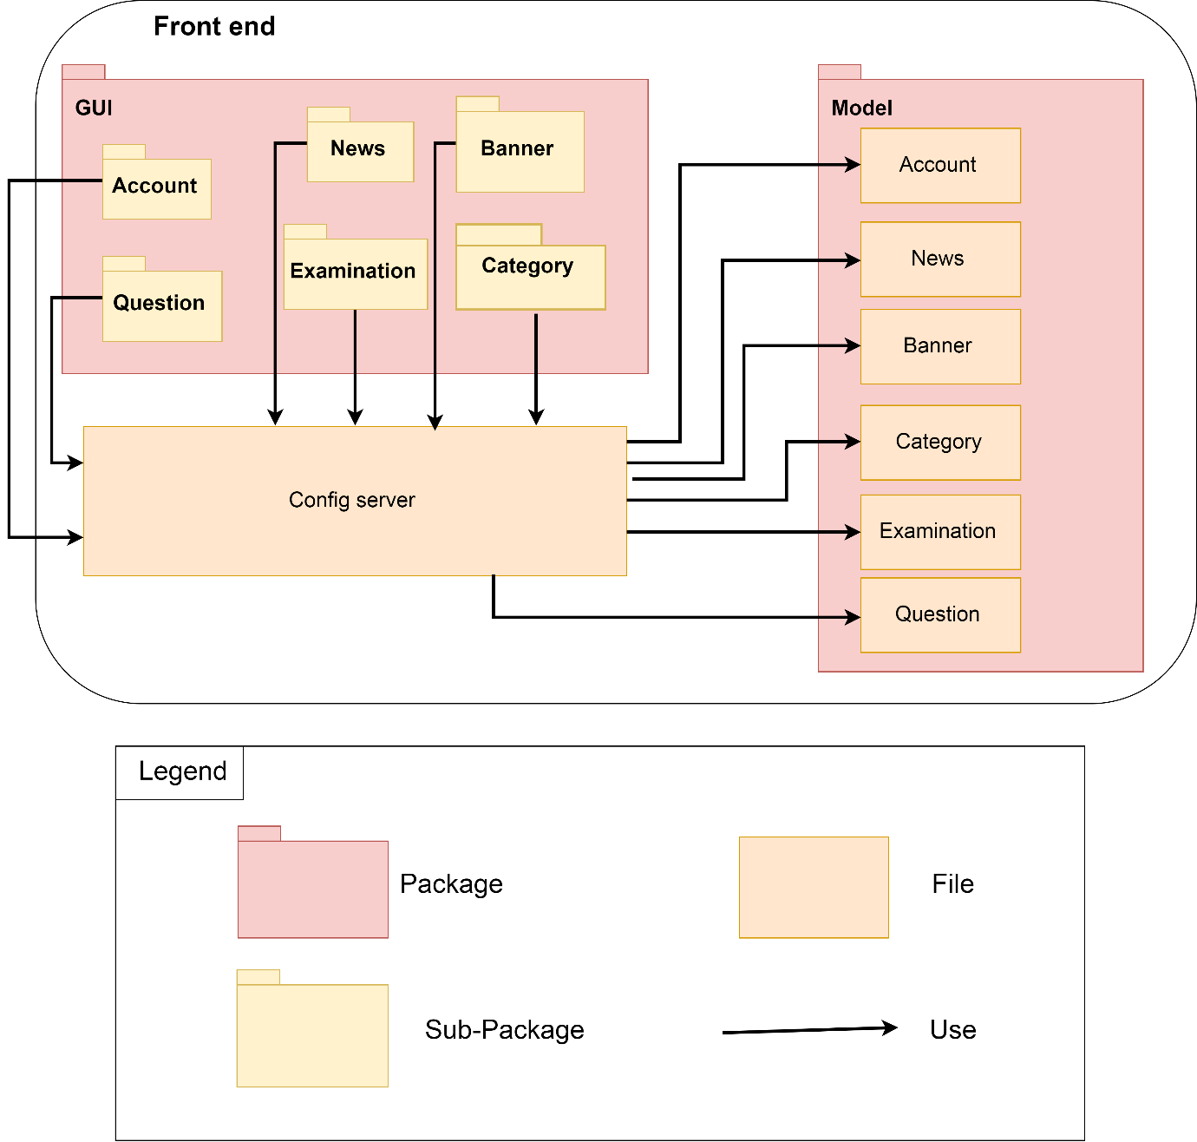

* + 1. Back end

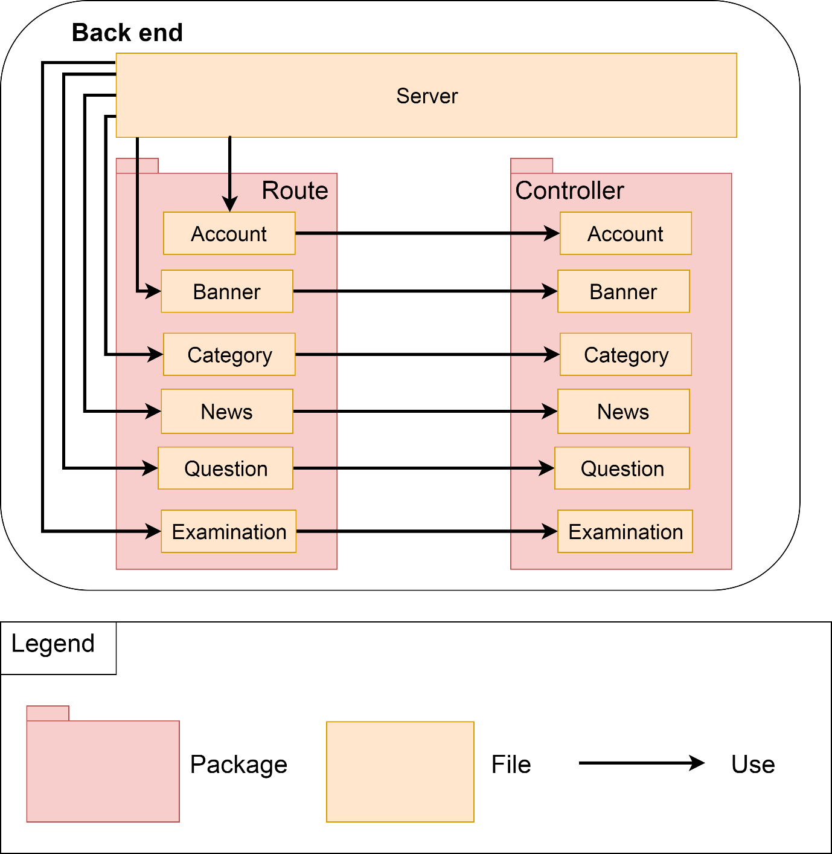

Rationale

|  |  |  |  |
| --- | --- | --- | --- |
| **No** | **Quality Attribute** | **Decision** | |
| 1 | Performance | We use No-SQL database for increase performance. | |
| 2 | Usability | System have a beautiful and friendly interface, easy to use. | |
| 3 | Modifiability | Dividing many packages to easy maintain, config and modify code. | |
| Risk | | Trade off | Sensitivity point |
| * Use No-SQL, hard to connect between database. | | * Dividing many packages will make assessing data a little slowly. |  |

1. DYNAMIC PERSPECTIVE
   1. PRIMARY PRESENTATION

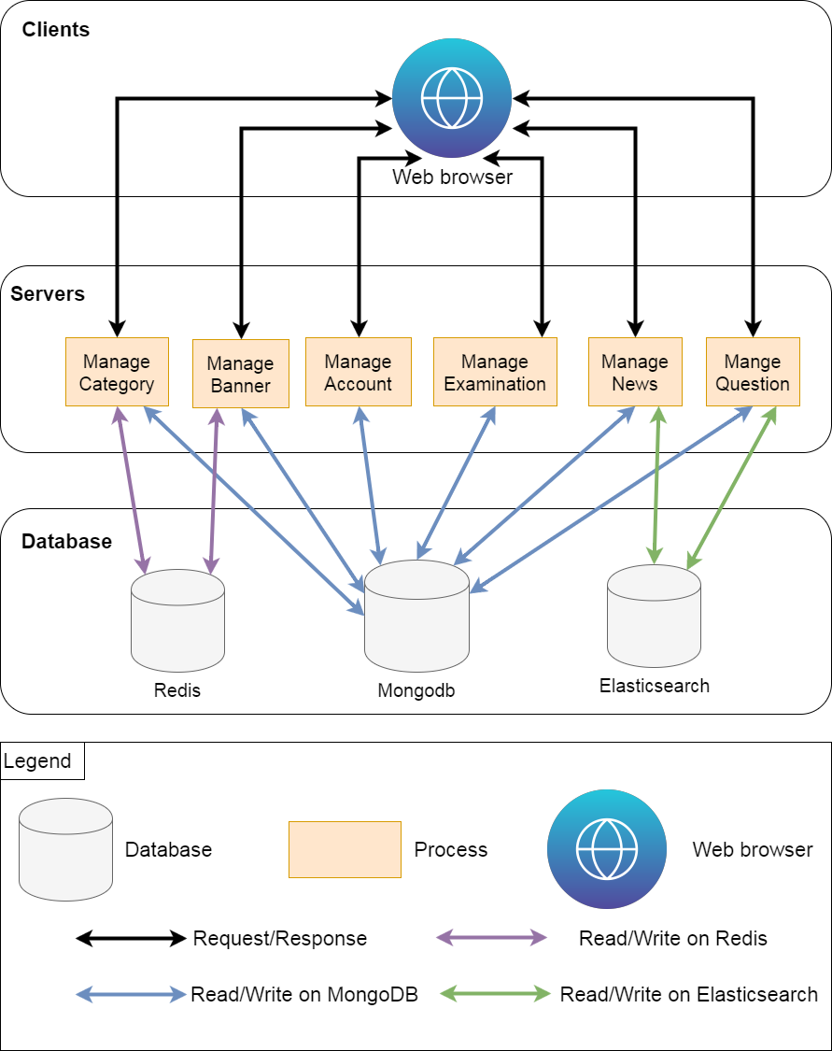

* 1. DECOMPOSITION STYLE
     1. News
        1. Select

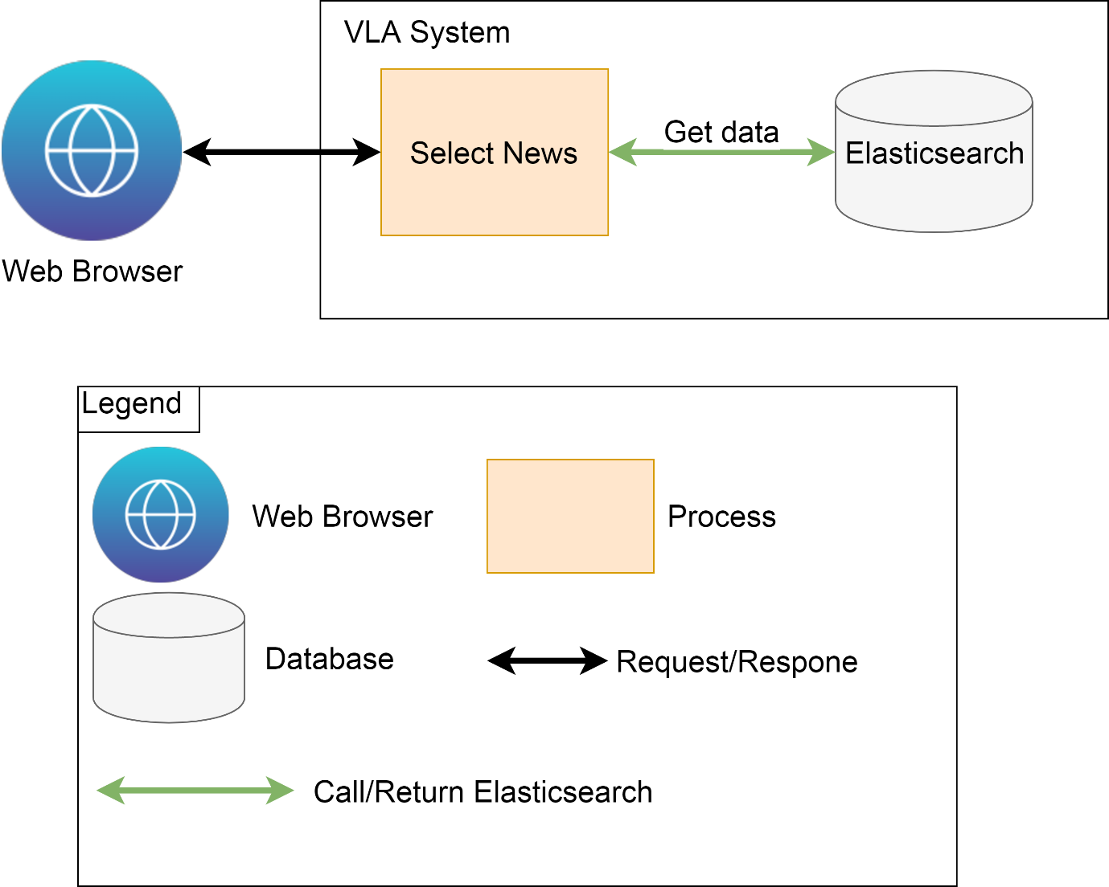

* + - 1. Create

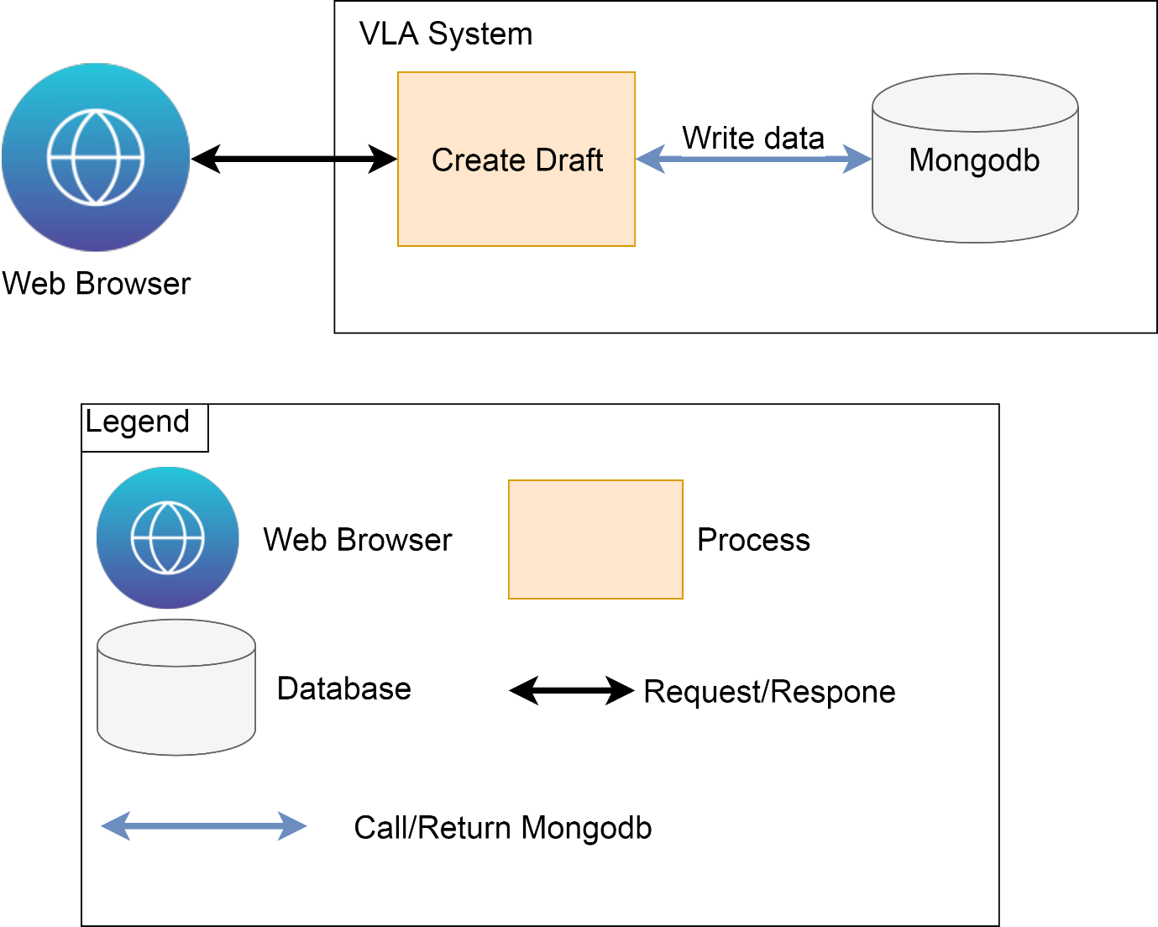

* + - 1. Post News

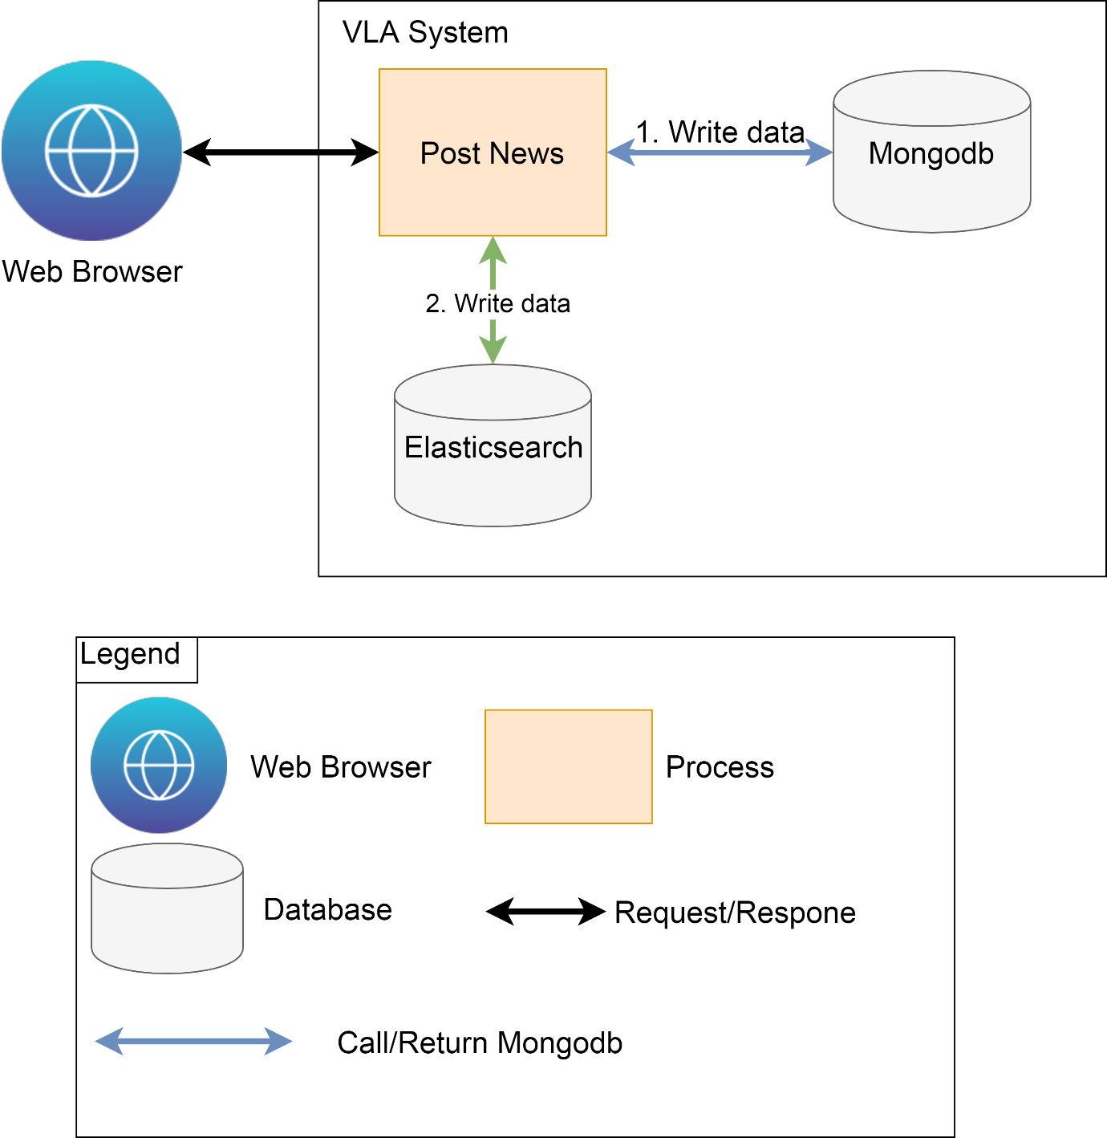

* + 1. Account
       1. Select

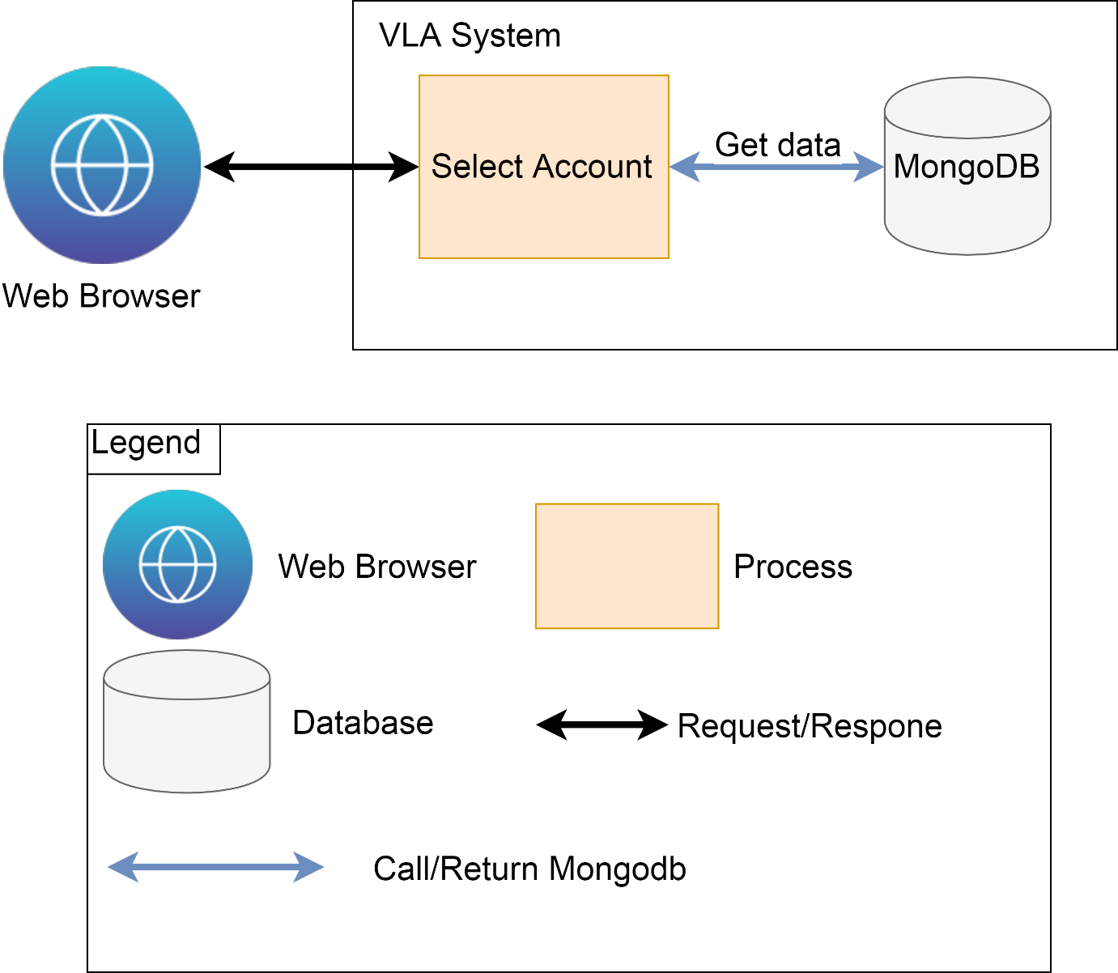

* + - 1. Greate

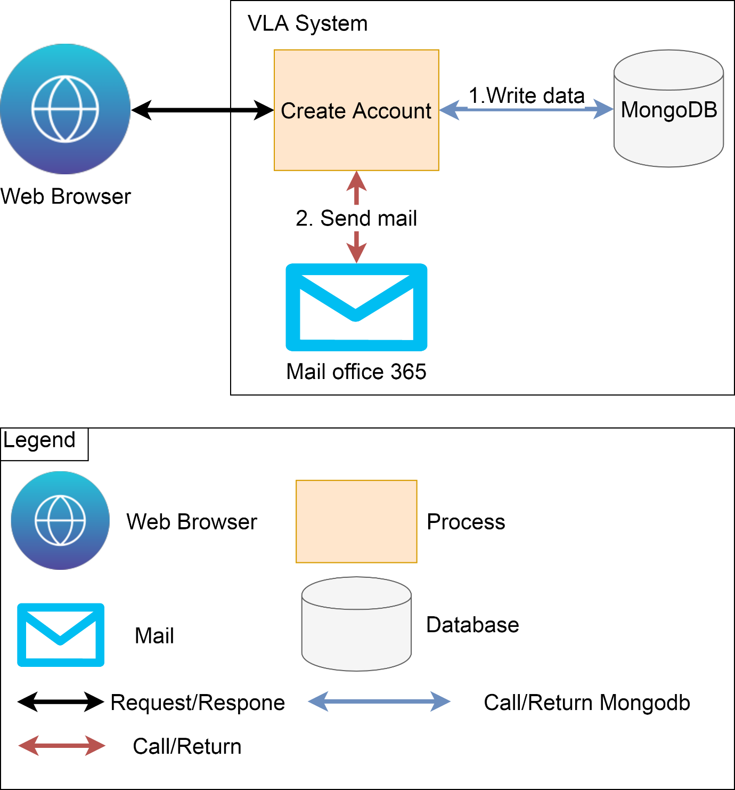

* + 1. Banner.
       1. Select

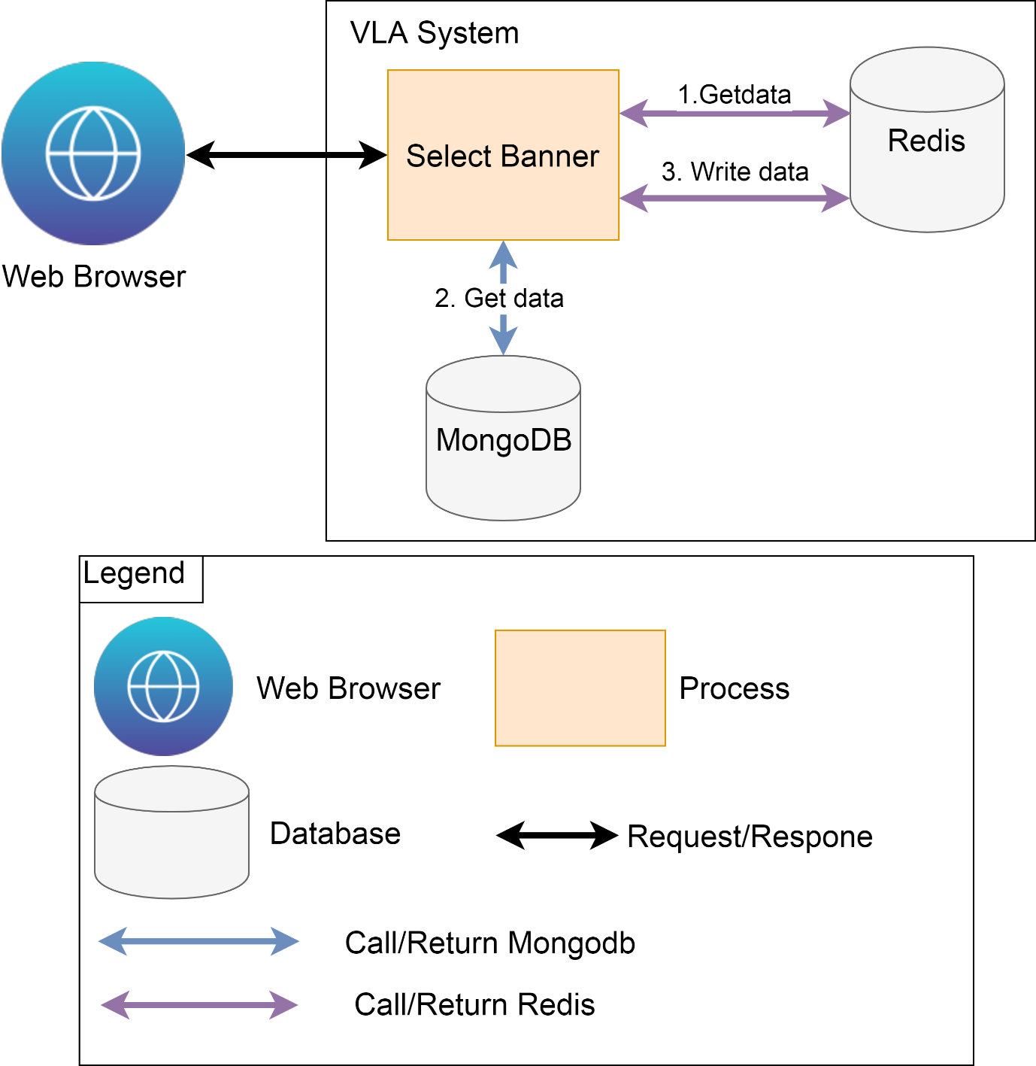

* + - 1. Edit

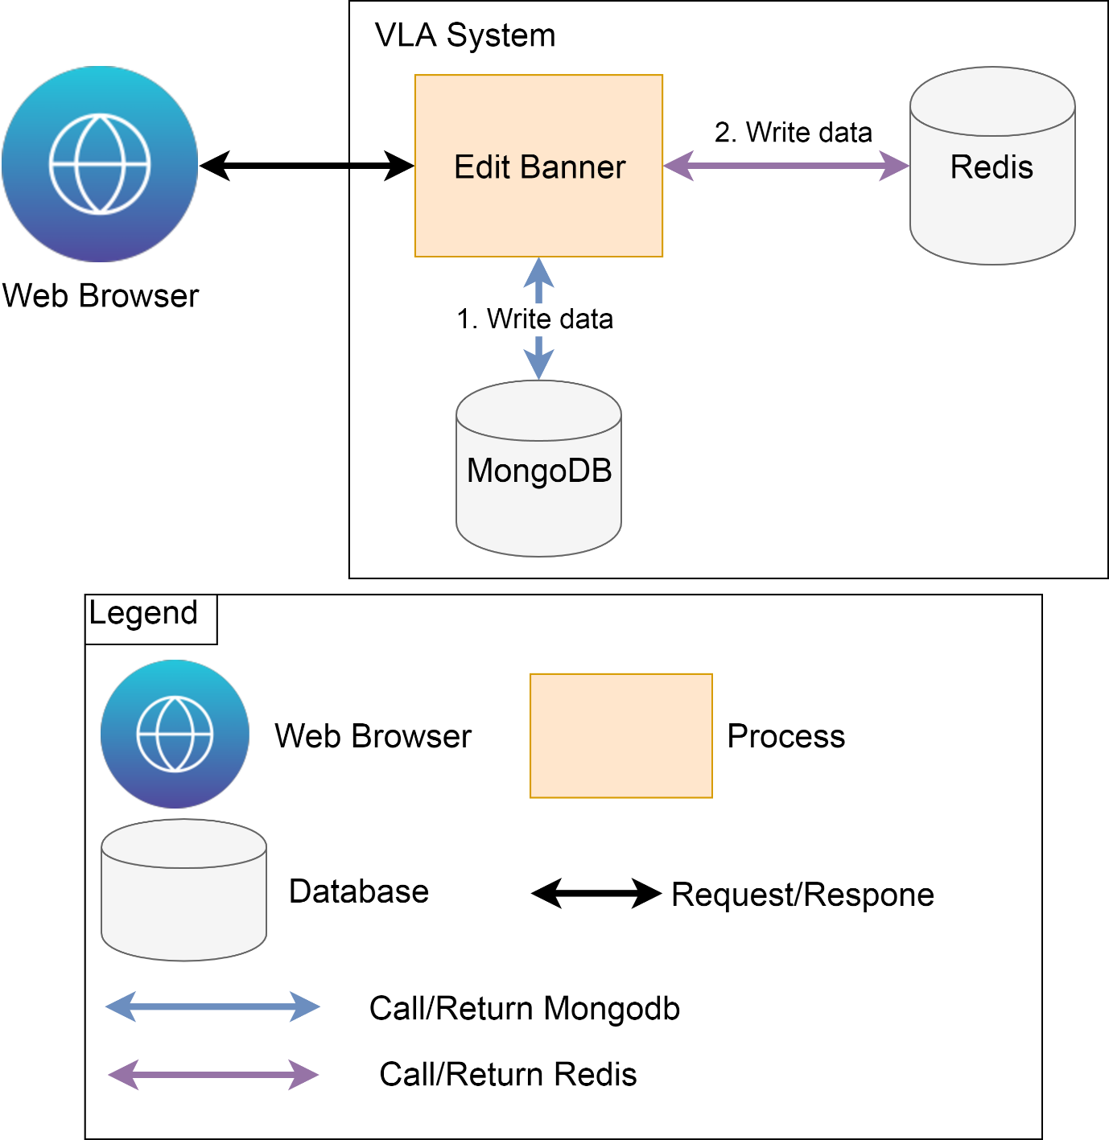

* + 1. Category
       1. Select

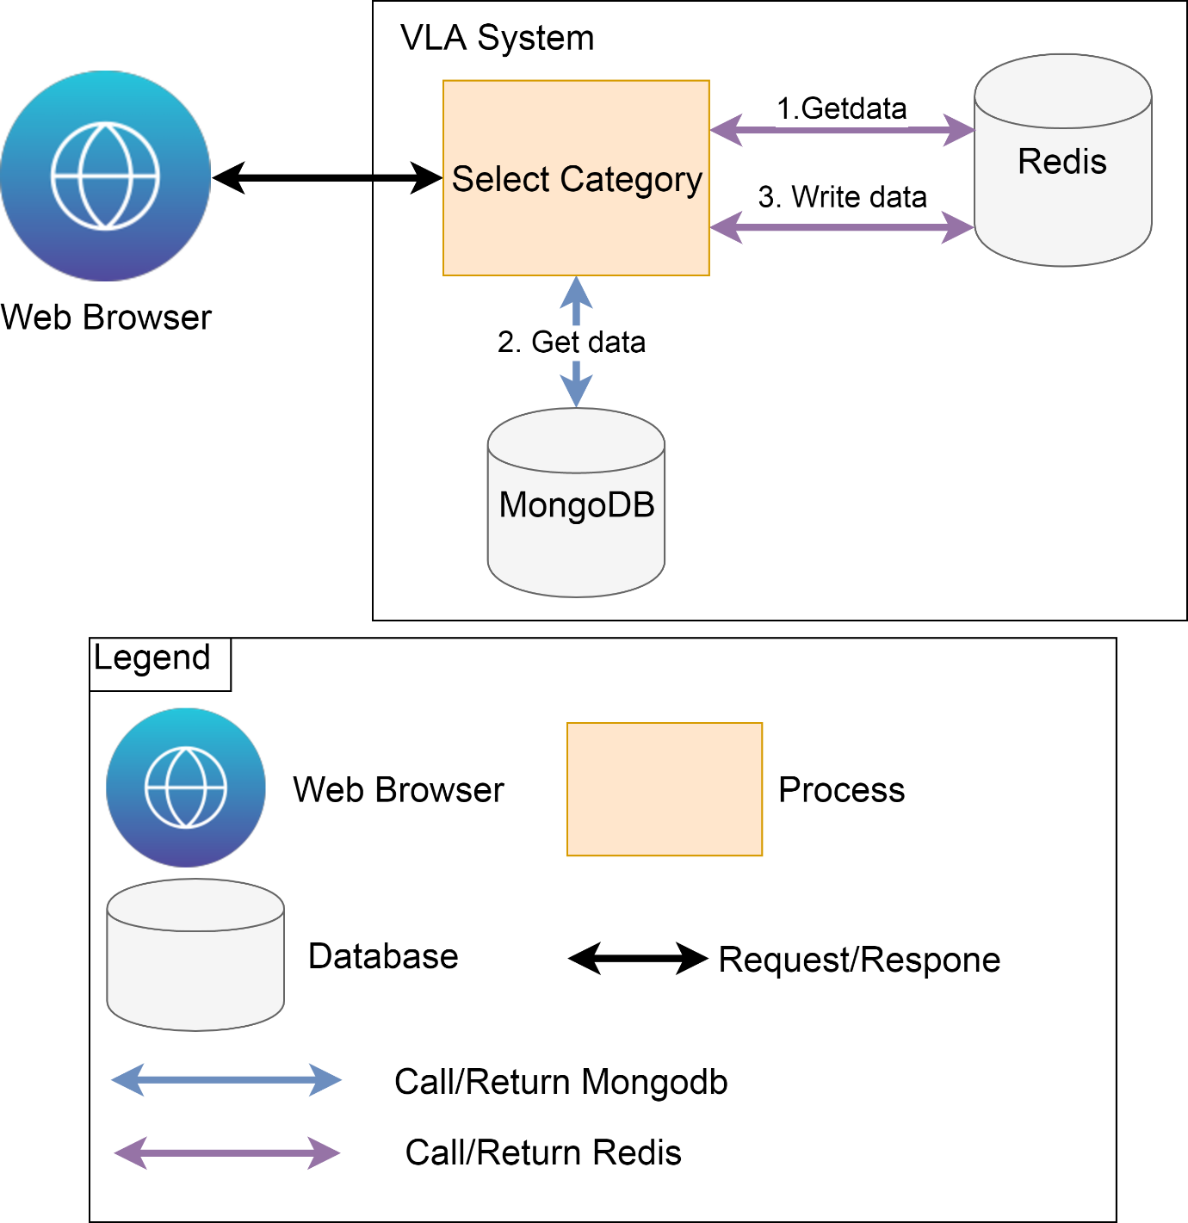

* + - 1. Edit

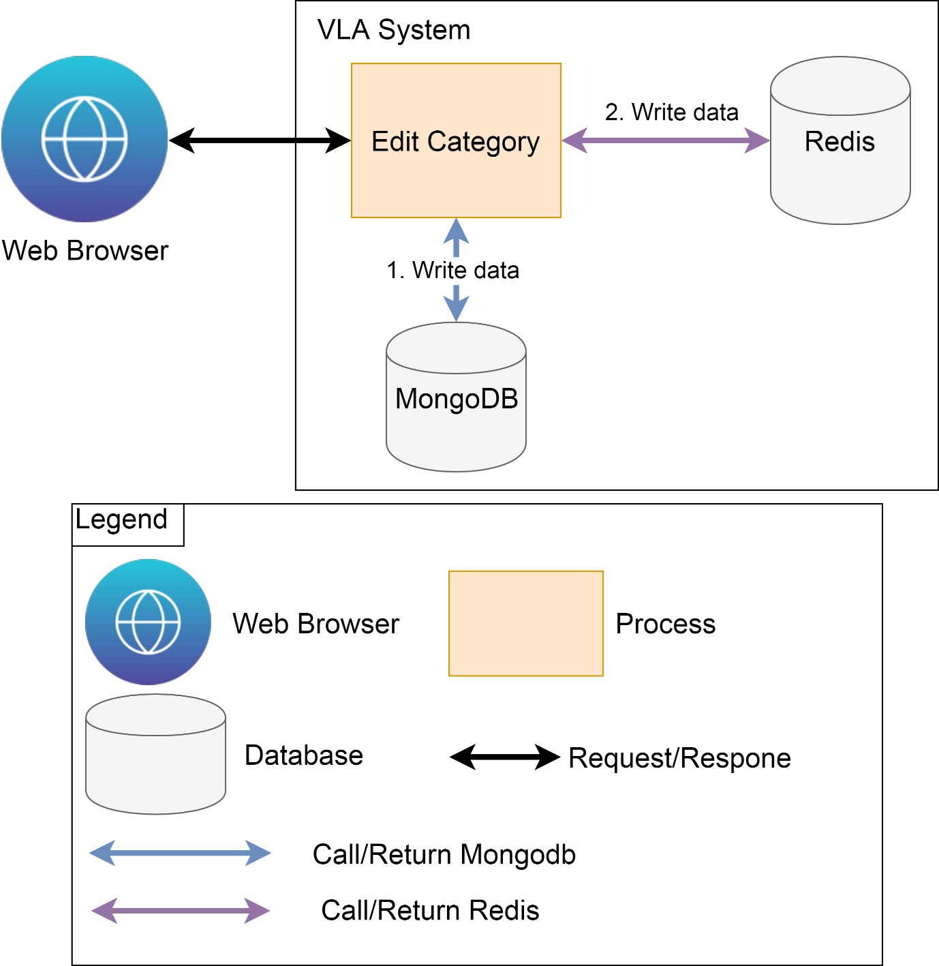

* + 1. Examination
       1. Import Student

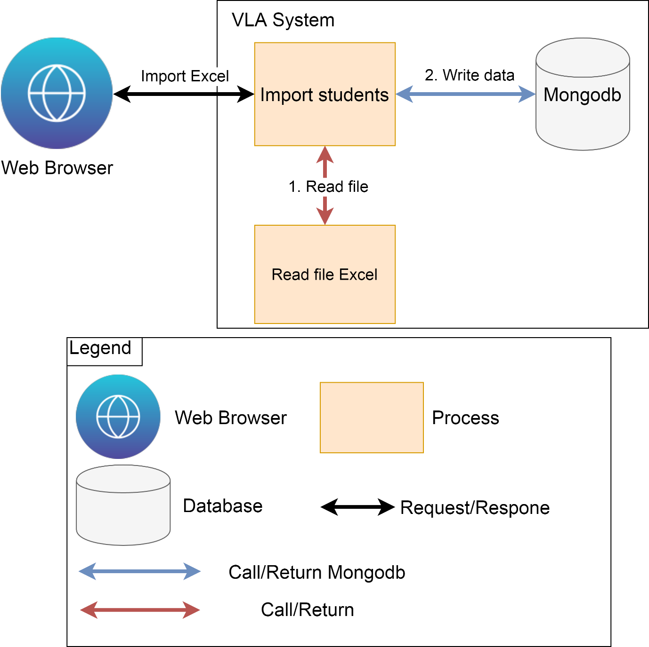

* + - 1. Select

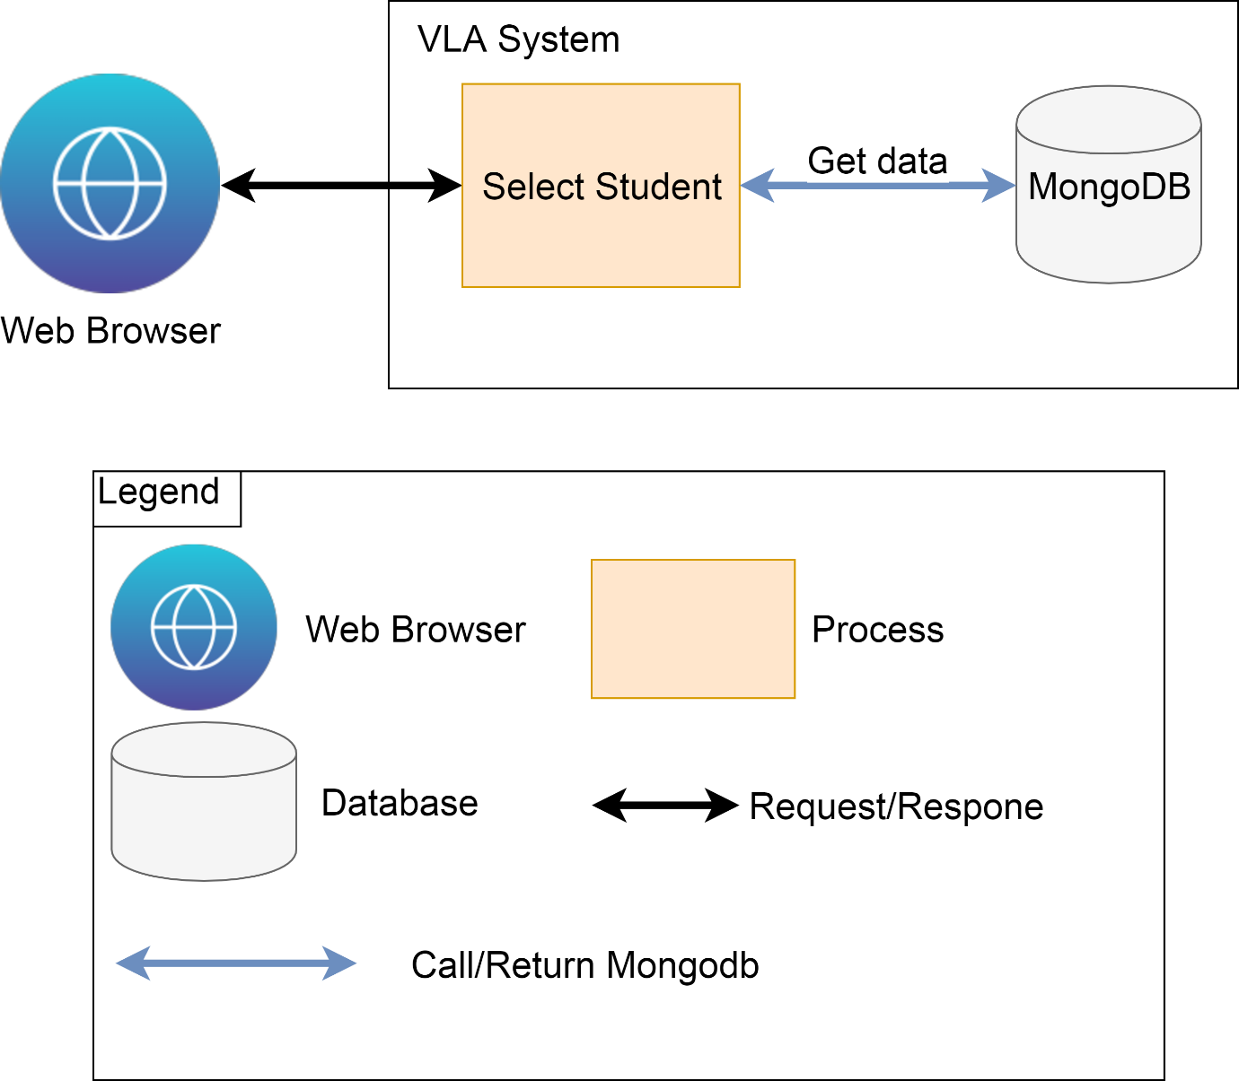

* + 1. Question
       1. Select

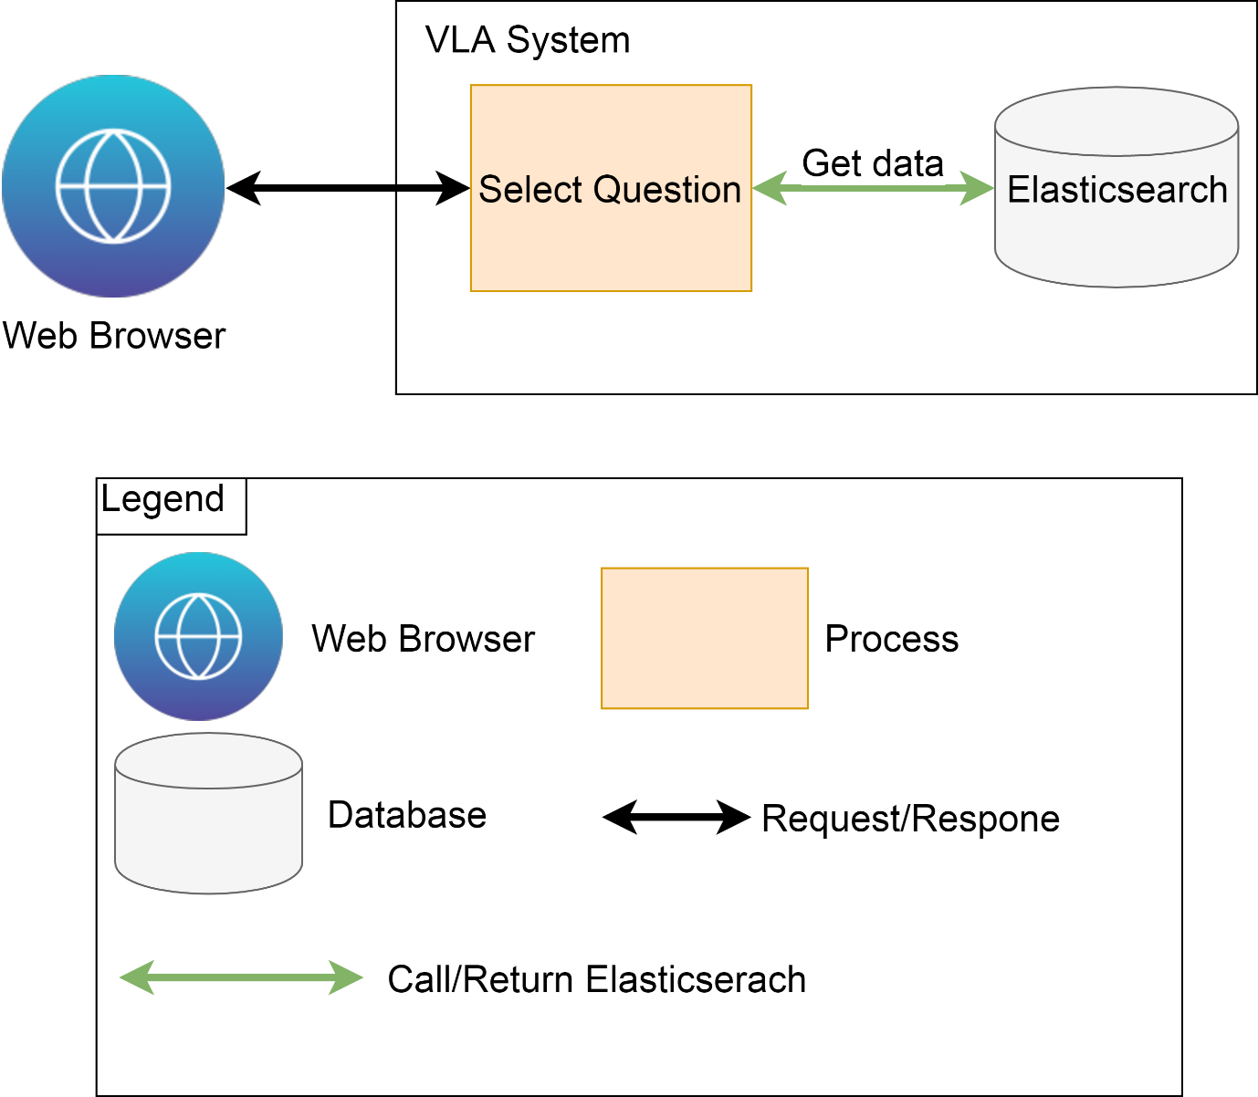

* + - 1. Create

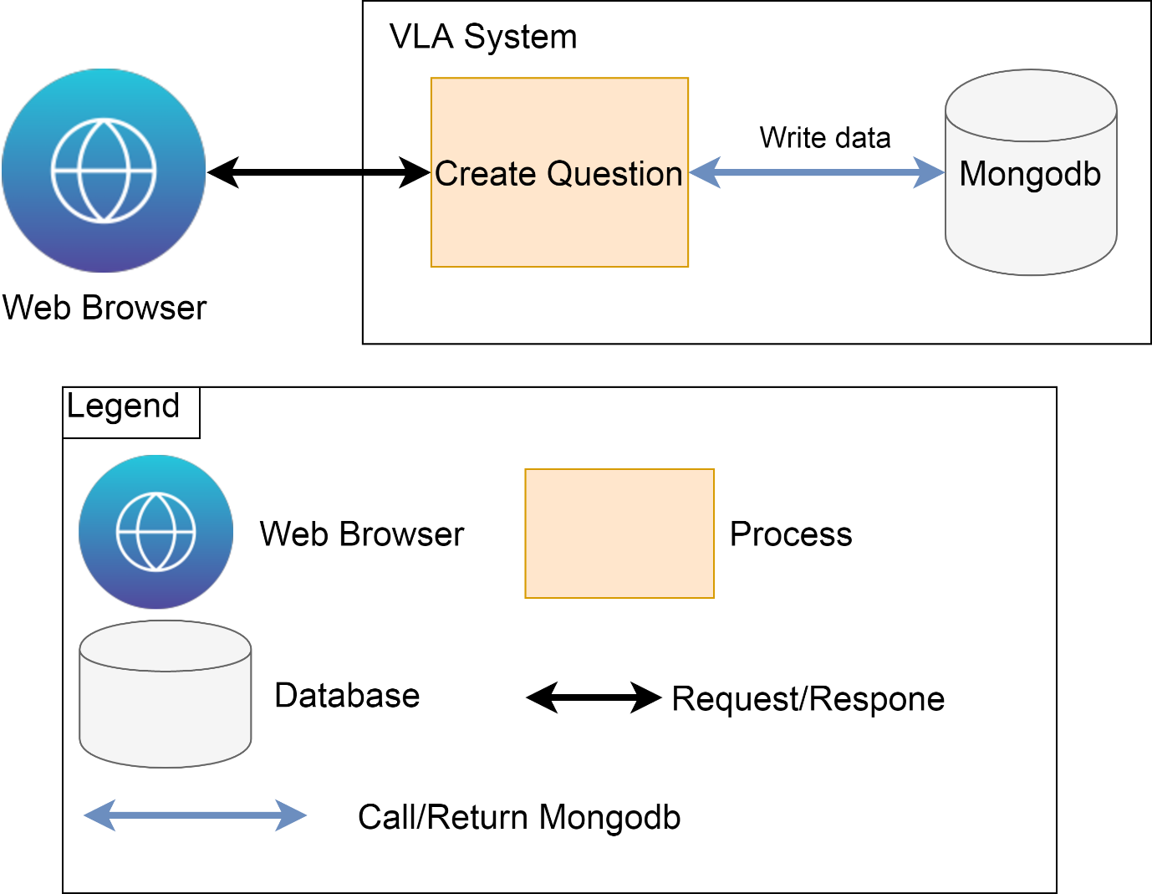

* + - 1. Answer

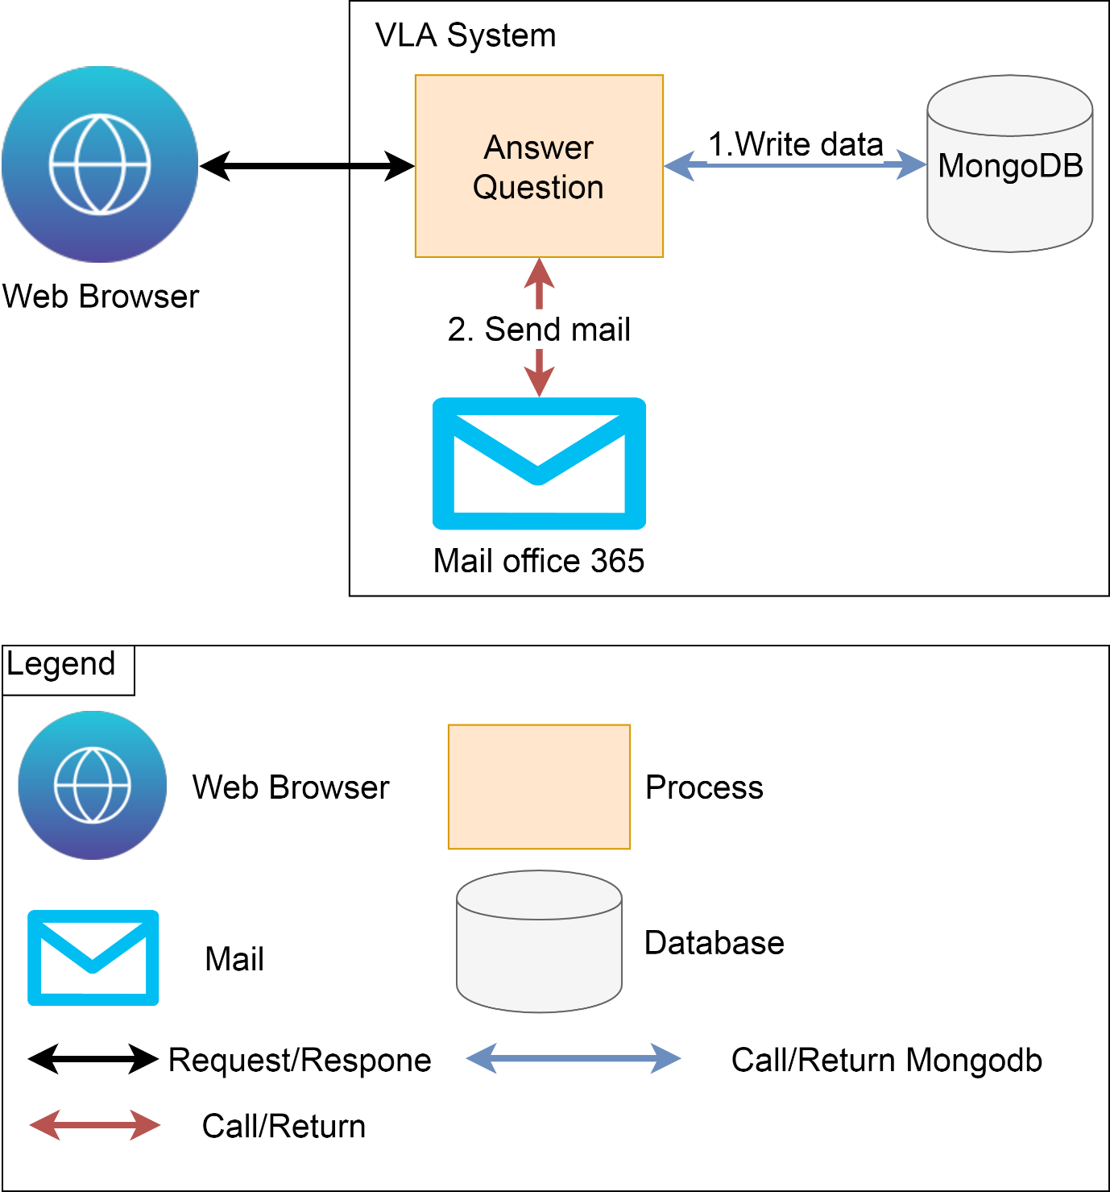

* + - 1. Approve Question

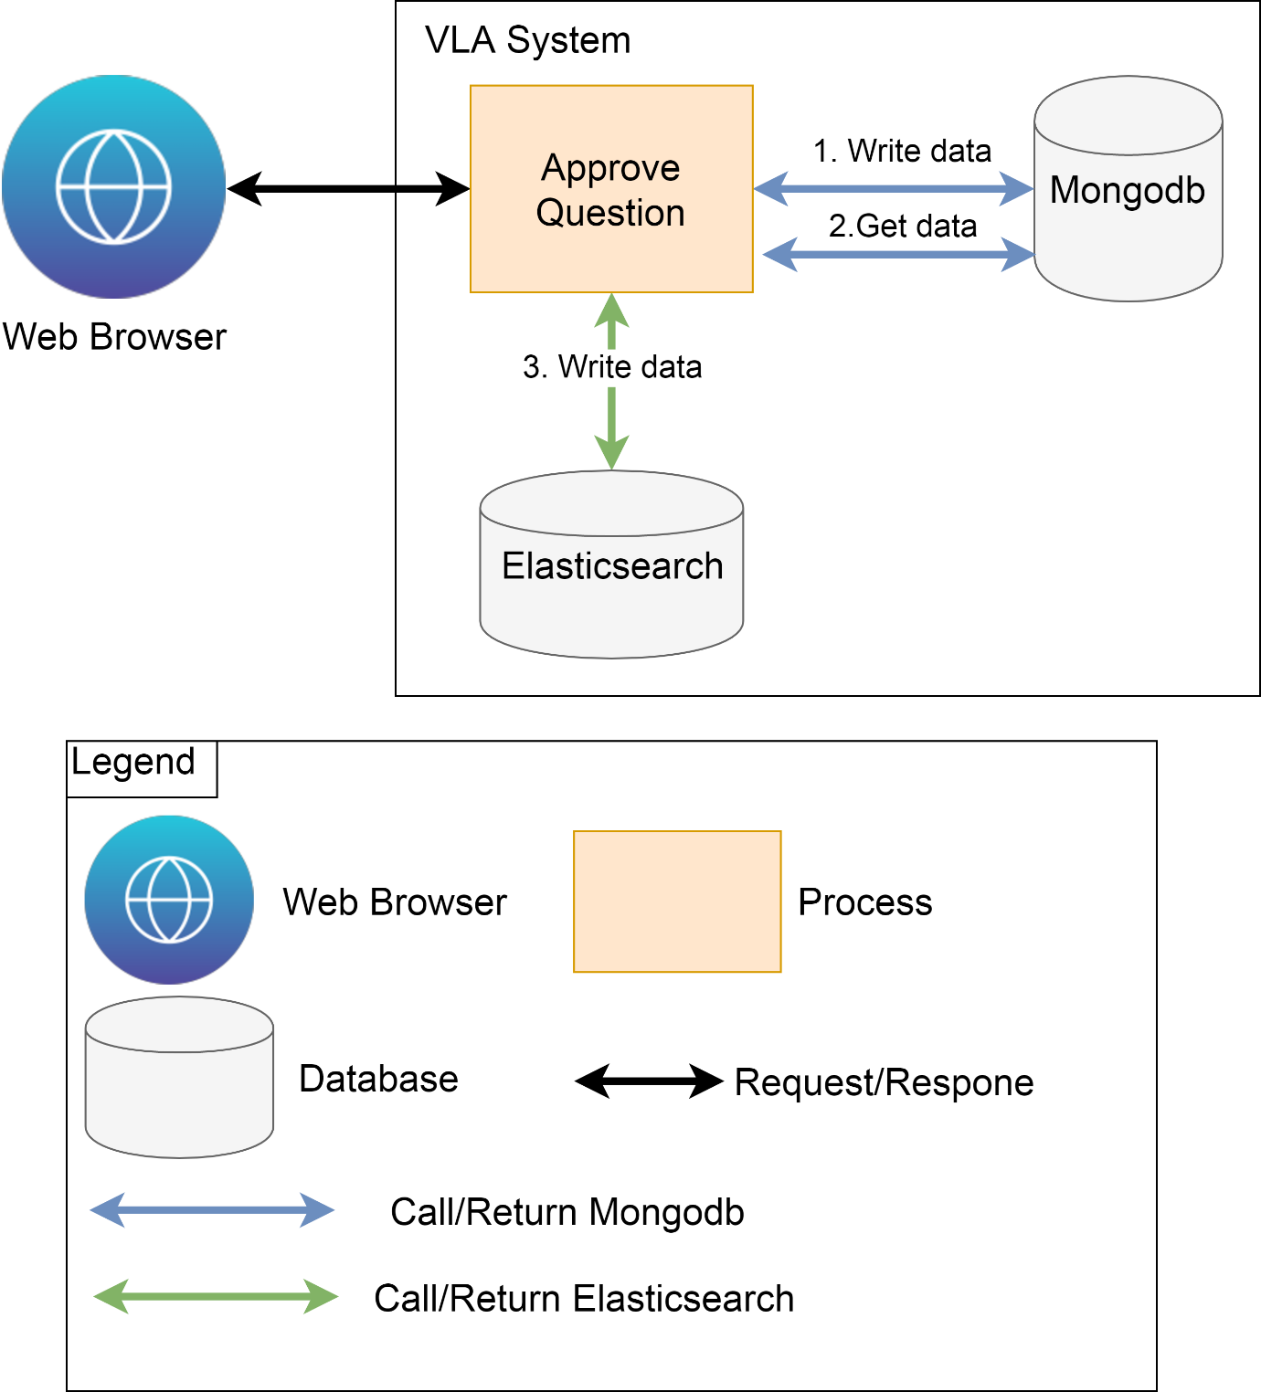

Rationale

|  |  |  |  |
| --- | --- | --- | --- |
| **No** | **Quality Attribute** | **Decision** | |
| 1 | Performance | We use Redis and Elasticsearch to get data more quickly. | |
| 2 | Security | Password will auto generate and transfer to account’s email. | |
| Risk | | Trade off | Sensitivity point |
| * Sometimes mail couldn’t send to user’s email. | | * Use Redis and Elasticsearch, spend much time to research them. |  |